Range and Range Stack Display HMI for BEV – CGEA1.3

Functional Description

The Range Display HMI for BEV will display DTE for the Battery. This STSS also describes Range Stack behavior, which means how Electric Range and Distance to Destination (DTD) will be placed on HMI display.

Destination ICON with Distance to Destination (DTD) will be shown based on destination location. It will show a flag symbol if the end point is Final Destination and it will show a Charge Port symbol if the end point is charging station. CAN signal has provision to show Home or Work symbol for future implementation.

The Distance To Destination (DTD) HMI for BEV will display distance from current coordinateness to next destination which can be final destination or some charging station (Waypoint) on the trip.

The Distance to Destination display HMI for BEV uses DistToStopover_L_Actl, to determine the DTD Display to be shown while Electric Range Display HMI for BEV uses VehElRnge_L2_Dsply, to determine the Range Display to be shown.
StopoverType_D_Stat will decide the destination Icon to be displayed with DTD.

Interfaces

Interface Context Diagram (I/O Block Diagram)

Range Stack Display for BEV Context Diagram

Inputs

IR-REQ-386695/A-Internal

  - Operational_Mode
  - Display_Units_MC

MUX signals

SIG-REQ-386685/A-VehElRnge_L2_Dsply Signal

Signal  Name | Size  (bits) | Detail | Units | Resolution | Offset | State  Encoded | Min. | Max.
VehElRnge_L2_Dsply | 13 |  | km | 0.1 | 0 |  | 0  (0x0) | 818.9  (0x1FFD)
 |  | Unknown |  |  |  | 0x1FFE
 |  | Faulted |  |  |  | 0x1FFF

SIG-REQ-386686/A-DistToStopover_L_Actl Signal

Signal  Name | Size  (bits) | Detail | Units | Resolution | Offset | State  Encoded | Min. | Max.
DistToStopover_L_Actl | 13 |  | km | 0.1 | 0 |  | 0  (0x0) | 818.9  (0x1FFD)
 |  | Unknown |  |  |  | 0x1FFE
 |  | Faulted |  |  |  | 0x1FFF

SIG-REQ-386687/A-StopoverType_D_Stat Signal

Signal Name | Size  (bits) | Detail | Units | Res. | Offset | State Encoded | Min. | Max.
StopoverType_D_Stat | 3 |  | SED | 1 | 0 |  | 0 (0x0) | 7 (0x7)
 |  | 0x0 |  |  |  | Null
 |  | 0x1 |  |  |  | Final Destination
 |  | 0x2 |  |  |  | Charge Station
 |  | 0x3 |  |  |  | Home
 |  | 0x4 |  |  |  | Work
 |  | 0x5 |  |  |  | Other
 |  | 0x6 |  |  |  | NotUsed_1
 |  | 0x7 |  |  |  | Fault

SIG-REQ-386688/A-BattTracLoSoc_D_Dsply Signal

Signal Name | Size  (bits) | Detail | Units | Res. | Offset | State Encoded | Min. | Max.
BattTracLoSoc_D_Dsply | 2 |  | SED | 1 | 0 |  | 0x0 | 0x3
 |  | 0x0 |  |  |  | Null
 |  | 0x1 |  |  |  | LoDte
 |  | 0x2 |  |  |  | ZeroDteDepleted  Battery
 |  | 0x3 |  |  |  | NotUsed_1

REQ-386699/A-Outputs
Electric Range display
Distance To Destination (DTD) Display
Range Stack

Function/Performance

F-REQ-386700/A-Operational Modes

Mode | Differentiating Vehicle Conditions
Sleep Mode | Range Display HMI Off
Limited Mode | Range Display HMI Off
Normal Mode | Range Display HMI On/Off
Crank Mode | Range Display HMI On/Off

Voltage Levels

Refer to Cluster Features table located in Operational Modes and Voltage Range Strategies Section in this SPSS.

Human-Machine Interface

Visual

Indicator Graphics / Display Format
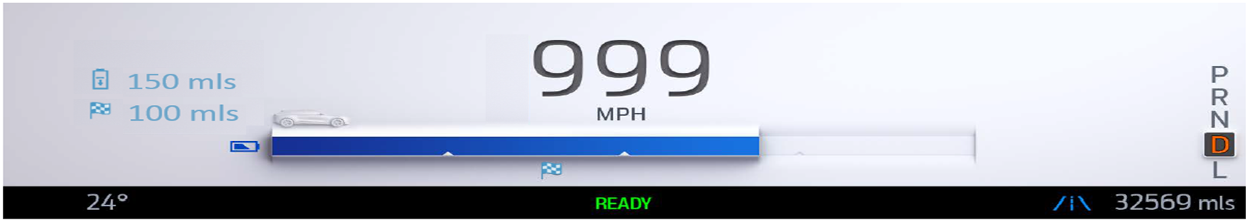
Reference HMI for Cx727

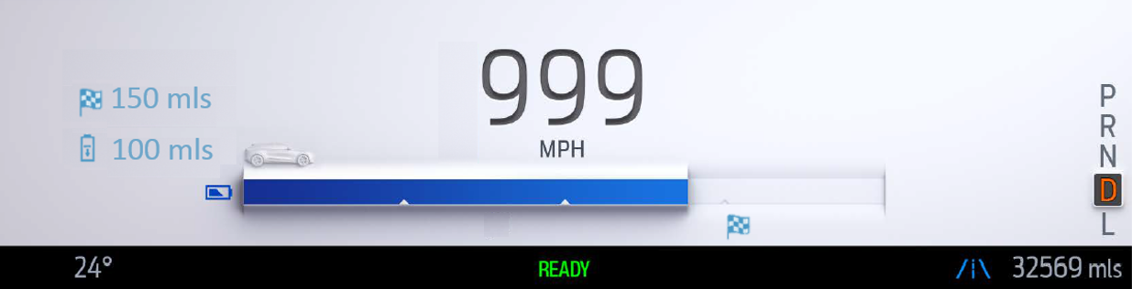
Electric Range < Distance to Destination (DTD)

Reference HMI for Cx727

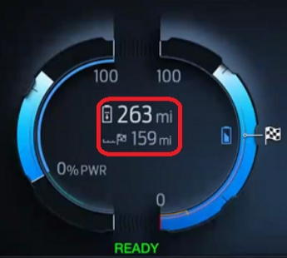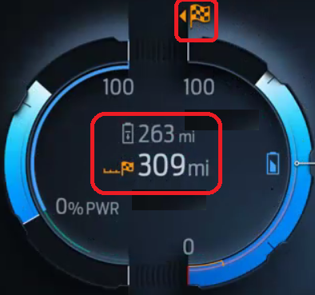
Reference HMI for P702
All these graphics provided are samples for better understanding. Actual graphics are to be provided by Ford HMI or Studio and approved by the DI Application for each program

Indicator Color Coordinates

Reference Ford HMI or Studio Wallpaper files for the specific program.

Indicator Characteristics

Reference Ford HMI or Studio Wallpaper files for the specific program.

Audio

None

Switch Control Logic

N/A

PFM-REQ-386701/A-System Accuracy

- Within a 100msec of receiving a message/input that results in a change of state the cluster will update the display to the proper status.
- Shall use kilometer to miles conversion constant of 1/1.609344

Operation: Performance and Functional

Subsystem Algorithm Flowchart / State Diagram

F-REQ-386689/A-Range Display for BEV Routine

F-REQ-386690/A-Electric Range Calculation

Note: “CEILING” is a Microsoft Excel Formula.

Operation Description (supports algorithm flowchart /state diagram)

F-REQ-386691/A-Missing Message Behavior

- If VehElRnge_L2_Dsply is missing or faulty or unknown, then Electric Range should show “- - “
- If DistToStopover_L_Actl is missing or faulty or unknown, then Distance To Destination should show “- - “

F-REQ-386692/A-Range Stack Order

- Range Stack Order (Cx727):
- Distance to Destination (DTD) will be on top of Electric Range if Electric Range < Distance to Destination.
- In all the other cases Electric Range will be on top.
- Range Stack Order (Default (e.g. P702):
- Electric Range will be on top
- Distance to Destination (DTD) at bottom
- Higher value will be highlighted. (in below example Electric Range is higher, hence highlighted)
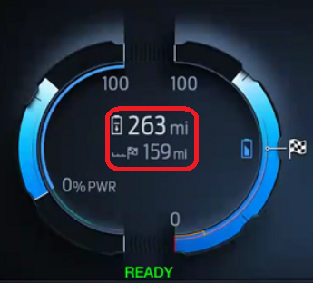
e.g. P702 HMI

F-REQ-386693/A-Electric Range Text Color
Electric Range Text will change color will be changed based on input CAN signal BattTracLoSoc_D_Dsply. (Graphics example not available, please refer program specific HMI specification)

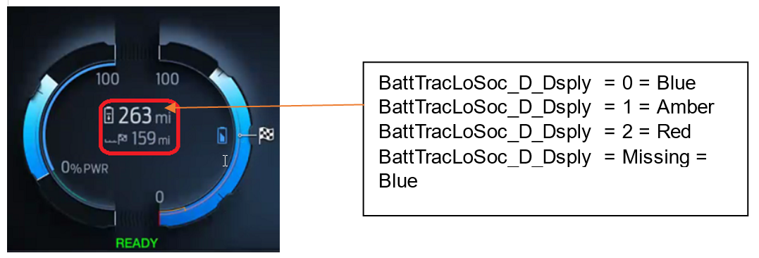

F-REQ-386694/A-Distance to Destination (DTD)

Distance to Destination (DTD) ICON will change based on Destination selection in CAN signal StopoverType_D_Stat. It can be a Flag symbol if destination point is Final destination or it will be a charge port if destination point is charging station. Please refer latest HMI delivery for ICON graphics.
StopoverType_D_Stat | DestSocRqd_Pc_Dsply | Destination Icon
StopoverType_D_Stat | DestSocRqd_Pc_Dsply | Range Stack | SOC Gauge
0x0 (Null) or Missing  as per section 1.4.1  (No active route) | X | None | None
0x1 (FinalDestination) | Destination SOC < Battery SOC | 
0x1 (FinalDestination) | Destination SOC >Battery SOC
0x1 (FinalDestination) | Destination SOC >100% |  |   Amber with Arrow
0x2 (ChargingStation) | X | 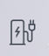

In some programs Distance to Destination (DTD) ICON color will not change with Gauge Fill percentage. (e.g. Cx727). Some programs may have different behavior, please refer program specific HMI.

- If StopoverType_D_Stat = 0x0 (No Trip), we show only Range and no Distance to Destination.
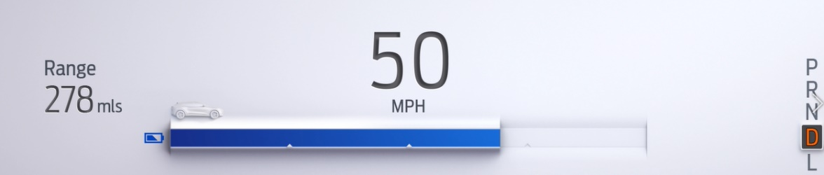

- Distance to Destination is determined by CAN signal DistToStopover_L_Actl

FS-REQ-386702/A-Function Safety Classification (EMC)

Class B

NVM-REQ-386696/A-Memory Storage

Parameter Name | Description | Value at Battery connect | Value at  Module Wake-up
Display_Units_MC | Defined as an output in Unit Selection Control Function STSS.  Input to this routine that controls display indicating units to the driver (i.e. when English: miles, mpg; when Metric: km, L/100 km, km/L). Parameter is to be stored in Battery Backed RAM. | Used Stored Value (See Display Unit Selection Control Function STSS) | As per Display Unit Selection Control Function – CGEA1.3 STSS
VehElRnge_L2_Dsply (CAN) Signal | CAN signal sent from the PCM for Remaining Distance | As per CAN Message List | Do Not Init
DistToStopover_L_Actl | CAN signal sent from the PCM for Distance To Destination | As per CAN Message List | Do Not Init
StopoverType_D_Stat | CAN signal sent from the APIM for Destinaton location. | As per CAN Message List | Do Not Init
BattTracSoc_Pc_Dsply | CAN signal Battery state of charge (SOC) | As per CAN Message List | Do Not Init
ElectricRange_Display | Output indicator for Electric Range display | 0x0 | 0x0
Range_Stack | Range_Stack is the logic to decide location of Electric Range and Distance To Destination(DTD) on Cluster HMI | Use stored Value | Use Stored Value
Operational_Mode | Input to this routine that is a 4 State indicator for cluster operational mode | As per Operational Modes and Voltage Range Strategies Section (STSS) | As per Operational Modes and Voltage Range Strategies Section (STSS)

Prove Out
No

Message Center Msg
Refer to Ford Studio Drawing

Reconfigurable Telltale
No

Error Handling

Missing Message Strategy

The signals will be declared missing as per the Diagnostics Section of this SPSS.

DTC states and history will be determined as per the Diagnostics Section of this SPSS.

Invalid Data Strategy

The signals will be declared invalid as per the Diagnostics Section of this SPSS.

DTC states and history will be determined as per the Diagnostics Section of this SPSS.
.

Diagnostics

Self Test

None

Engineering Test Mode

Reference section “Dealer / Engineering Test Mode (ETM)”

Part II Performance

DTC-REQ-386697/A-Supported Diagnostic Trouble Codes (DTCs)

DTC | Description
C29300 | Lost Communication with Hybrid/EV Powertrain Control Module
C59400 | Invalid Data Received From Hybrid/EV Powertrain Control Module

DCR-REQ-386698/A-DID DExx

Block  Num | Block Description | Byte(s) | Bits | State: Description | "0" | "1" | Default | Comments/  Information
$09 | Option Content (B&A) |  | 3 | PT Hybrid2(PT_Hyb_Cfg2)  0x0 = Non-Hybrid  0x1 = BEV  0x2 = FHEV  0x3 = PHEV  0x4 = MHEV |  |  | 0x1 | Default from cluster plant to be 0x1as this STSS is specific to BEV.

Reference Specification

None

Revision History

SPSS Module Revision History

Revision Level | Name | Change Description | Date
1.0 | H. Sharma | Initial Release:  Initial Release based upon EPE team (Charbel Bouery/Dale Gilman) “DIDC Requirements for 21MY Cx727 Electric Range HMI BEV Change Requests. This request was brought to DICC on 24th Jan 2019 and approved to create a new STSS. | 1/31/2019
1.1 | H. Sharma | This request was brought to DICC by Charbel Bouery and approved offline by Scott Watkins on 04/21/2020.  DICC tracking # 540. Changes are marked in Turquoise color.  In this revision there are three main updates:  - Update in Range Stack Order  - Electric Range Text color  - DTD Symbol updates.  Following sections of STSS are updated to implement these changes:  - Section 1.2.1 Context Diagram updated to add new CAN signal ‘BattTracLoSoc_D_Dsply’,  - New CAN signal ‘BattTracLoSoc_D_Dsply’ is added to section 1.2.2.2.4.  - Section 1.3.3.1.1 Indicator Graphics / Display Format is updated to add new graphics example.  - Section 1.3.5.2 is updated to add new display requirement for Range Stack, Electric Range text color and DTD symbol updates.  - Section 1.3.5.4 NVM-REQ-386696/A-Memory Storage is updated to add new CAN signal.  - Section 1.5.3.1 DTC-REQ-386697 is updated to remove diagnostic code C12100 as none of CAN signals coming from ABS. | 04/27/2020

